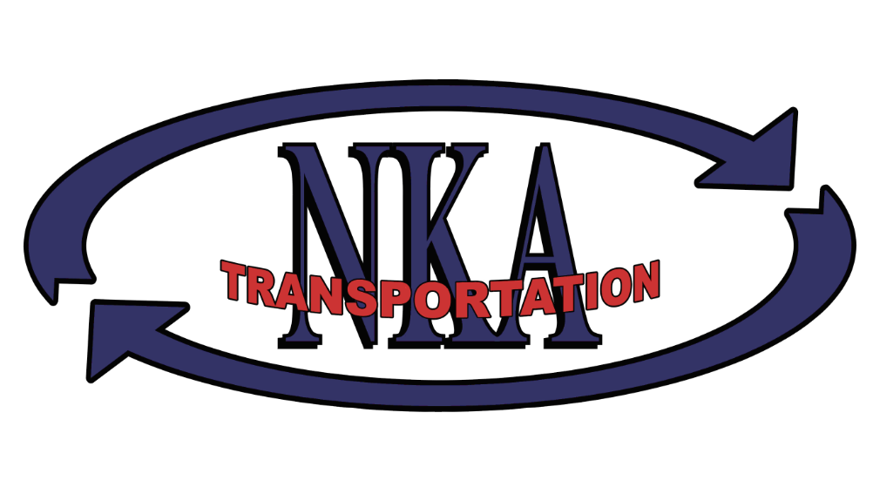

**(937) 498-4651 Ext. 2222**

**CLASS A CDL DRIVERS**

**NOW HIRING**

**NKA Transportation**

**www.nkparts.com/careers**